**THE CHEWBACCA II**

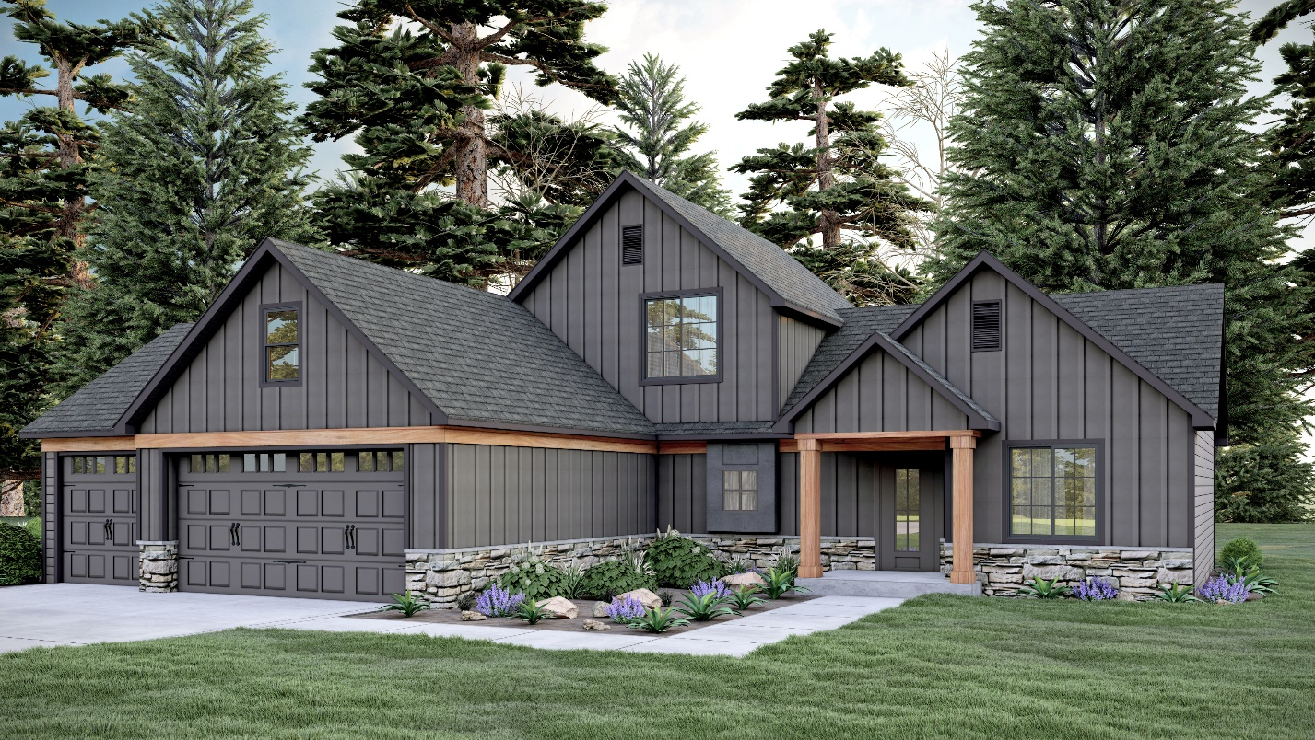

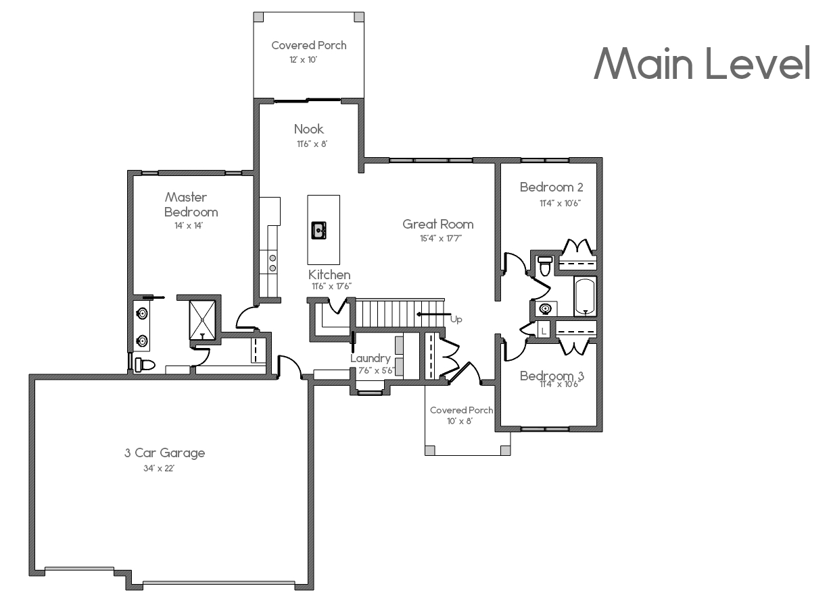

* 2047 SQFT
* 3 BEDROOMS
* 2 BATHS
* 3 CAR GARAGE
* OPEN LIVING CONCEPT

HOME SQUARE FOOTAGES ARE APPROXIMATE AND ARE SUBJECT TO CHANGE. ALL HOME PLANS CAN BE PLACED ON A BASEMENT.